The Vastu of Altars:
Creating Sacred Space in Your Home

Vastu is the science of building or arranging your home with the optimal balance of the elements to create the highest vibration flow of energy for your health, happiness and wealth.
An altar literally means “a table for God”. An altar is a sacred space with a surface for the presentation of religious or spiritual offerings and focus. They are found in shrines, temples, churches, other places of worship and can be created in your home and/or office.
So the vastu of altars would mean how to create a sacred space in your environment (indoors or outdoors) that balances and harmonizes the elements in order to achieve the most optimal flow of energy for your intentions in life. A beautiful reference for this work is the book by Robin Mastro titled, “Altars of Power and Grace”.
What you need to build an altar:
- Space you would like to dedicate as sacred space in your environment
- A surface
  - A low table or the top of a dresser, mantle, piano, countertop, wall niche, end table, sofa table, window seat, etc…Use your imagination and the space you have available to determine where it will go.
- An altar cloth
  - Tie in culture, symbols, purpose, and the color of the direction (see below).
- What kind of alter do you want?
  - Relationship, Motherhood, pregnancy
  - Support of community and loved ones
  - Healing
  - Spiritual growth
  - Career
  - Abundance, prosperity
  - Creativity
  - Life change or growth
- An objective or statement of purpose or a personal symbol of your intention
  - Handwrite a purpose on a piece of pretty paper
  - Print something out on the computer
  - Use affirmation cards
  - Have a picture or a book or symbol that represents for you what you want to keep as your sacred intention in your heart and mind.

- An offering tray for the center
  - A pretty tray, bowl or container that can hold your purpose statement or symbol of intention.
  - Your emotion, those aspects of life and spirit that you hold dear.
  - Your unique vision or vocalization of your spirituality.
- The aspect of the Divine you would like to call upon
  - What faith tradition are you?
  - What is the part of you that you would like to grow that is part of the Divine?
  - What is the symbol you feel comfortable having out on an altar that represents the Divine?
    - Statues
    - Animals or other aspects of nature
    - Photos
    - Pictures of Saints, teachers, gurus, etc…
    - Sacred books
    - Sacred symbols
    - Prayer Flags
  - “Archangels and Ascended Masters” by Doreen Virtue is a nice reference for determining these questions.
- Cultivating the support of the Universe- the 5 elements and the 8 directions
  - Elements
    - Space (center)
      - A Container, bowl or vase
      - Hollow shell
      - Picture of the cosmos
      - A symbol like a star or spiral or the sun or moon or planets
    - Air (northwest)
      - A bell or wind chime
      - Incense
      - Anything that flies
      - Feathers
      - Fans, flags
    - Fire (southeast)
      - A candle
      - A volcanic rock
      - A picture of Pele (the Hawaiian volcano goddess)
    - Water (northeast)
      - Something that lives in the water
      - A picture of water
      - A vase of water
      - A symbol representing the zodiac water signs
      - A fountain
    - Earth (southwest)
      - Rocks/gemstones
      - Crystal salt lamp
      - Plant life
      - Anything heavy
      - A landlubber animal
      - A picture of any natural setting

  - Directions
    - North
    - Northeast: water
    - East
    - Southeast: fire
    - South
    - Southwest: earth
    - West
    - Northwest: air

- Activating your Altar
  - Sit before your completed alter and bring your intention to the space between your eyebrows and visualize what your purpose is for it.
    - Light a candle and some incense
    - Wave your incense over the alter in a clockwise direction 9 times
    - Ring a bell to announce your intention to the Universe
    - Chant, pray, meditate, sing (do a puja ceremony or ritual matching your faith tradition)
    - C all on your angels, archangels, guides, ancestors
      - Azrael: heals us from grief (color beige)
      - Haniel: helps women with their health and with clairvoyance (color pale blue)
      - Raguel: helps with relationships (color aqua)
      - Raphael: healing angel (color emerald green)
      - Zadkiel: helps with mental function and memory (color dark blue)
      - Chamuel: angel of peace and helps us find what we are looking for (color pale green)
      - Metatron: helps children with spiritual gifts and self-esteem (color green with dark pink)
      - Jophiel: helps us beautify our thoughts (color fushcia)
      - Ariel: helps with animals, nature and manifestation (color pale pink)
      - Michael: courage and protection (color purple)
      - Raziel: heals spiritual and psychic blocks (color rainbows)
      - Sandalphon: music (color turquoise)
      - Jeremiel: heals emotions (color violet)
      - Uriel: wisdom (color pale yellow)
      - Gabriel: communication, messengers and parents (color dark yellow)
    - Send your altar Reiki, compassion, the love of Christ or any other energy you like to work with.
    - Use planetary yantras and mantras (included in your vastu professional consultation package).
- Tending your Altar
  - Keep it clean and clutter free
  - Offer fresh flowers or fruit to it frequently
  - Feed it with appreciation
  - Pray, meditate, chant, sing, contemplate, send energy
  - Take pieces off that are no longer relevant for you…your altar should evolve and grow as your consciousness does.
  - If you no longer feel the power of your altar, start over with it…clean slate.

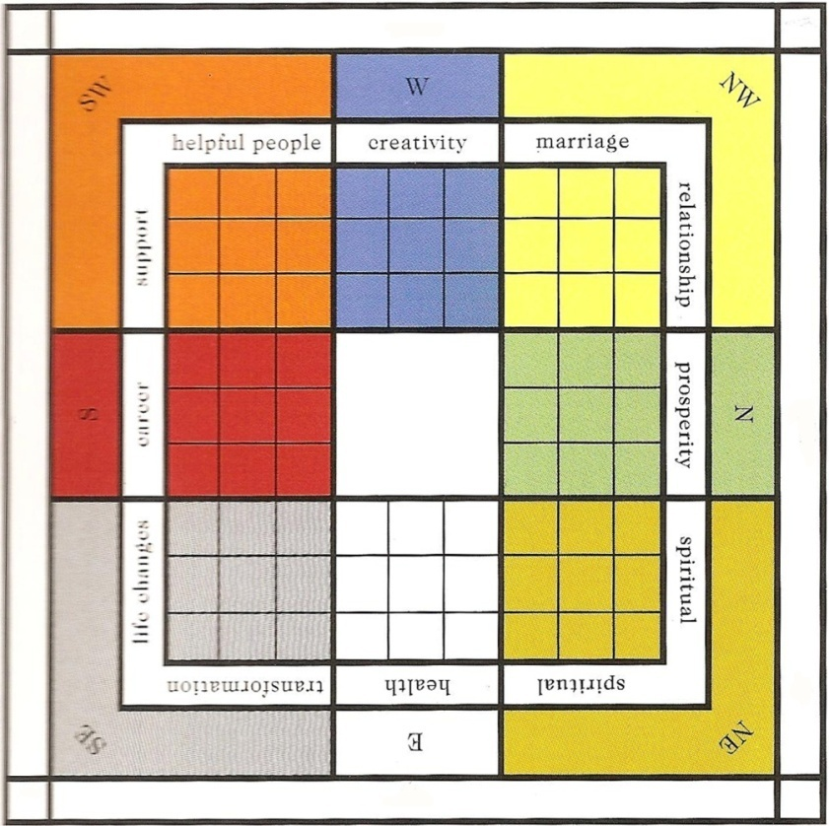

Chart courtesy of Vastu Creations.

Following are prayers and chants from various traditions. Please find what works for you. Each of these has been taught to me and I have been given permission to share them. Keep in mind the issue of cultural appropriation and permissioning when using any prayer.

Catholic/Christian Prayers

Hail Mary

Hail Mary,
Full of Grace,
The Lord is with thee.
Blessed art thou among women,
and blessed is the fruit
of thy womb, Jesus.
Holy Mary,
Mother of God,
pray for us sinners now,
and at the hour of death.
Amen.

Prayer of Saint Francis of Assisi

Lord, make me an instrument of your peace.
Where there is hatred, let me sow love;
where there is injury, pardon;
where there is doubt, faith;
where there is despair, hope;
where there is darkness, light;
and where there is sadness, joy.
O Divine Master, grant that I may not so much seek
to be consoled as to console,
to be understood as to understand,
to be loved as to love.
For it is in giving that we receive;
it is in pardoning that we are pardoned;
and it is in dying that we are born to eternal life. Amen

Steps of a Typical Hindu Puja
- Self -purification with water. This can be literal (washing of the hands) or symbolic (dipping a flower in water and sprinkling it on oneself).
- Ringing a bell. The sound of a bell creates pure vibrations, invoking divine forces in one’s heart and in the atmosphere and driving away negative influences.
- Intent (sankalpa). Fix in your mind the goal of the puja—for example, abundance, spiritual enlightenment, health, to embody love, and so on.
- Invoking the deity or higher power.
- Worship with offerings.
- Closing/surrender.

Brief Puja to the Goddess

INVOCATION
We meditate upon the supreme Goddess, who is robed in pure white raiment, the resplendent one, who is ever established in the supreme Truth, whose benign glances beam with binding love, the revered one whose divine face beams with a soft, graceful smile, who incessantly showers the nectar of motherly love, who sings the glories of God most sweetly, whose limbs shine with the complexion of a raincloud, whose words are soaked in honey; the supreme Goddess Herself, who is the very embodiment of immortal bliss.

Offering the invocation
Offering incense
Offering light
Offering water
Offering fruit
Offering water
Offering camphor light
White as camphor, compassion incarnate, the essence of creation garlanded with BRAHMAN, dwelling in the lotus of my heart, the creative impulse of cosmic life, to That I bow down.
Offering camphor light
Offering water
Offering a handful of flowers

Sanskrit Prayers
Om
Lokah Samastah Sukhino Bhavantu
Lokah Samastah Sukhino Bhavantu
Lokah Samastah Sukhino Bhavantu
Om Shanti Shanti Shantihi
Word for word translation:
Lokah (world) Samastah (all) Sukino (happy) Bhavantu (may be)
Meaning:
May all beings (in the three worlds) be happy.
Om peace, peace peace.

Planetary Mantras
To the Moon in the northwest for relationships chant: OM NAMO BHAGAVATE VASU DEVAYA NAMAHA
To Mercury in the north for finances: OM NAMO BHAGAVATE BUDDHA DEVAYA NAMAHA
To Jupiter in the northeast for growth: OM NAMO BHAGAVATE VAMANA DEVAYA NAMAHA
To Ketu at the entrance for protection: OM NAMO BHAGAVATE MATSYA DEVAYA NAMAHA
To the Sun in the east for health: OM NAMO BHAGAVATE RAMACHANDRAYA NAMAHA
To Venus in the southeast for energy: OM NAMO BHAGAVATE PARASURAMAYA NAMAHA
To Mars in the south for career: OM NAMO BHAGAVATE NARASIMHIYA NAMAHA
To Rahu in the southwest for support: OM NAMO BHAGAVATE VARAHA DEVAYA NAMAHA
To Saturn in the west for education: OM NAMO BHAGAVATE KURMA DEVAYA NAMAHA

