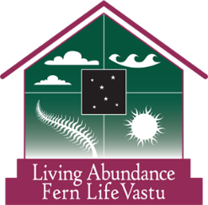
Vastu Home Self-Assessment

Welcome to Living Abundance Vastu Shastra consultations.

The science of Vastu Shastra allows for greater abundance in all areas of your life.

The ancient science of building, or Vastu Shastra in Sanskrit, is 7,000 to 10,000 years old and comes from the Vedas, the sacred texts of India which also gave us Yoga , Ayurveda (the science of life), and Jyotish (Indian astrology).

The Greek Parthenon, the Egyptian and Mayan pyramids, the Taj Mahal and the Roman Coliseum are all said to be influenced and built according the Vastu principles.
The Chinese art of feng shui actually came from Vastu 3,000 years ago. and was changed for geographical and cultural reasons.

Vastu is about balancing the 5 elements (air, space, fire, water, and earth) and 9 planets so that energy, or prana (known in Chinese as chi/qi), moves correctly through any given space.

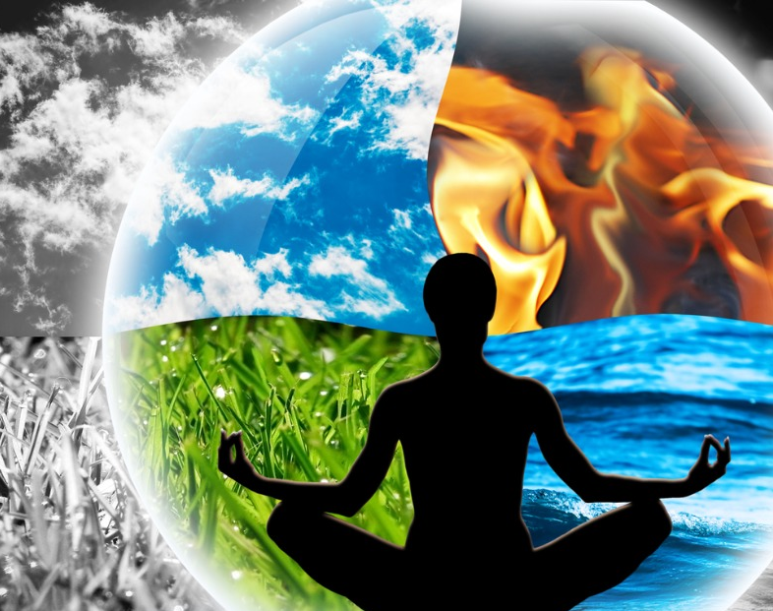
Optimal energy movement and placement of the elements brings greater harmony, prosperity, health, and less stress. This applies to any space, living, working, or playing. Ideally, the land and house you live in should line up with the poles of the Earth.

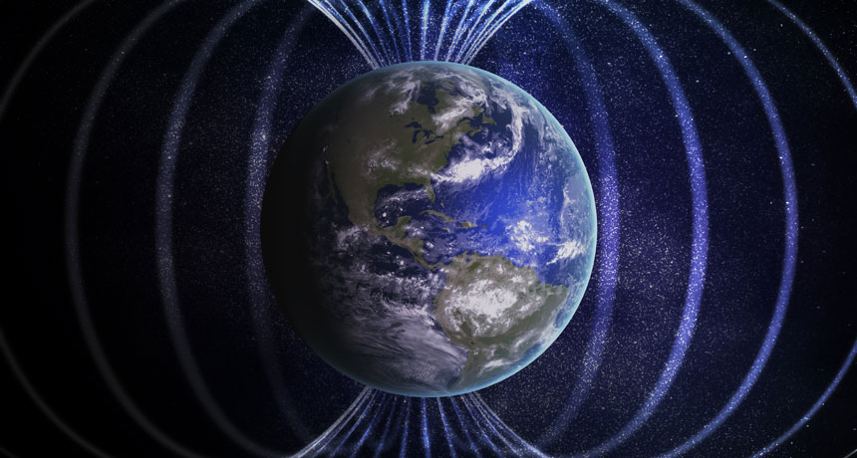
Magnetic energy comes from the North and since our bodies also mirror the poles of the Earth, with our heads being the North, it is not healthy to sleep with your head facing North (it repels all that beneficial energy which will affect your finances). It is not necessary to tear down walls or dig up areas of your lot. There are minor corrections and devices that can be used to help energy flow in the direction that brings optimal life abundance.

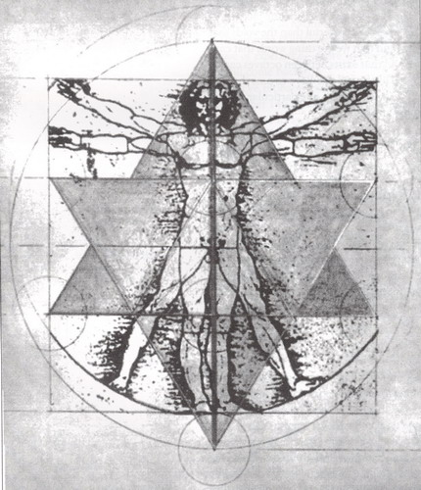
According to Ayurveda (the science of life) and Vastu (the science of building), we reach our potential health and harmony only when we are in balance. We are microcosms of the macrocosms of the Universe. In other words, the elements that make up the great outdoors, also make us and our environments up.

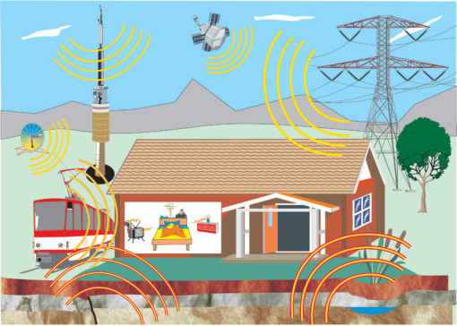
First there was sound, from sound came air. From the friction of air came fire. From the heat of fire came water and as the water evaporated, we got earth. Ayurveda reduces the stress in the body by balancing the five elements. Vastu Shastra also reduces stress by balancing the same five elements in the environment.
Vastu seeks to protect us from the harshness of the wind, rain, sun, geopathic imbalances and electromagnetic distortion.

The Cardinal Directions and Planetary Influences

A building can be sick with pollution…but also sick by not being in harmony with the elements, Earth, and directions. 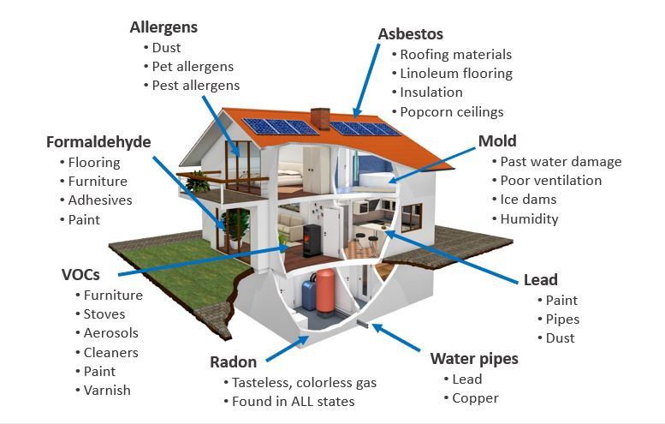

Energy flows in from the Northeast part of a building, splits, and moves around and settles in the Southwest. If there are missing corners or extensions in a structure some of that energy gets stuck and throws the five elements out of balance, creating stress.

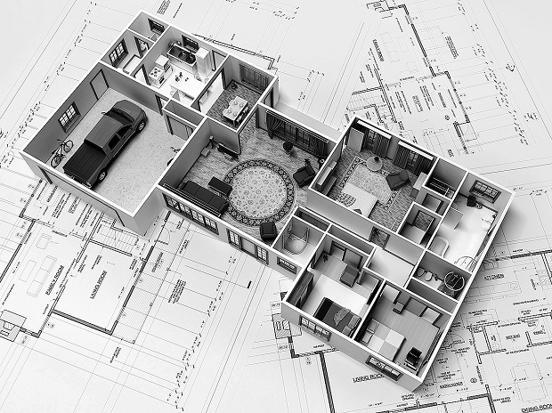
Blocks in the directional areas of your space will have negative impact on your life, whether it’s relationships, the mind, finances, health, spirituality, energy levels, career or general success in any area of life.

The Planets and Directions and Some of What They Influence
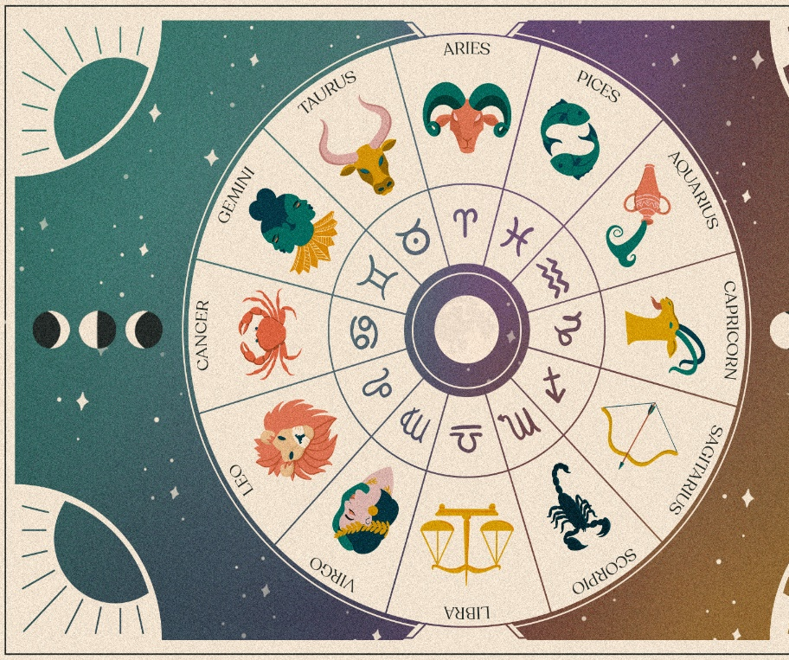
Northwest (Moon): Influences the mind and relationships
North (Mercury): Influences the throat and finances
Northeast (Jupiter): Influences the head and spiritual growth
East (Sun): Influences the heart and general overall health
Southeast (Venus): Influences the liver and energy levels
South (Mars): Influences the adrenals and career
Southwest (Rahu): Influences bones and support from family and friends
West (Saturn): Influences kidneys and education/creativity
Center (Sun): Influences the heart and communication/general overall success and prosperity.

It’s all about balance…

Home Assessment

Let’s see how your home and/or office does when assessed. Each of the sections below include a chart with the optimal directions on the left and the points you give your home/section on the right. Tally each section and when the quiz is done, tally all of the scores obtained from each area.

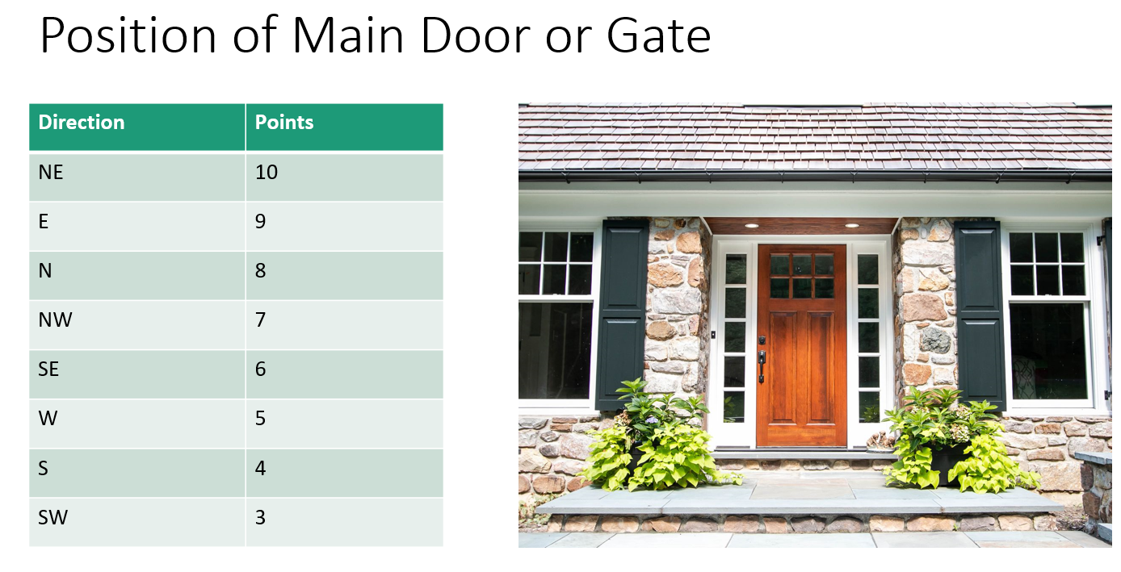

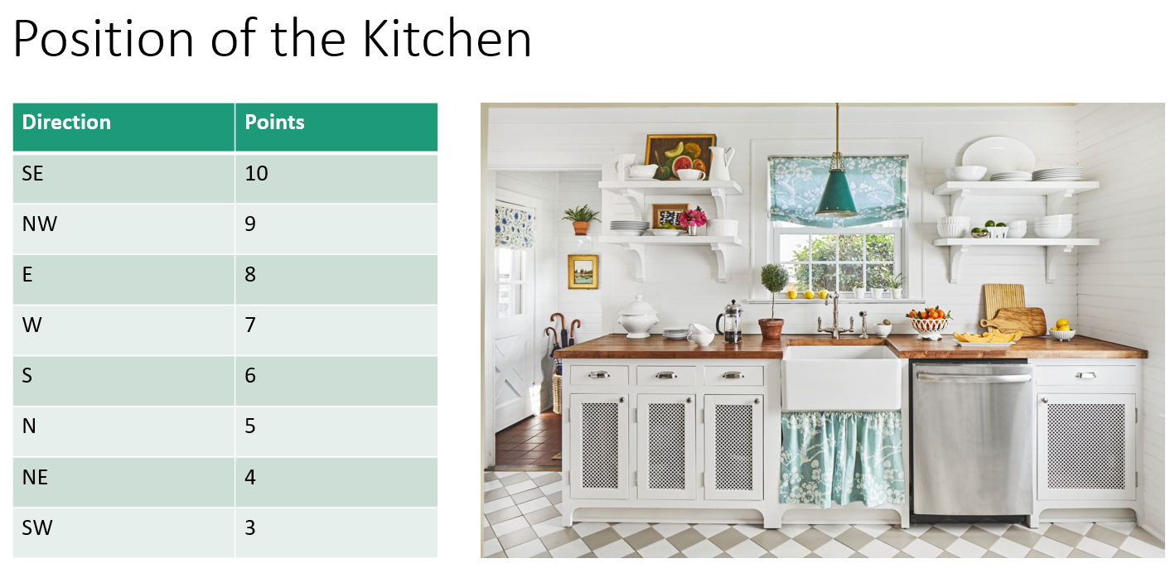

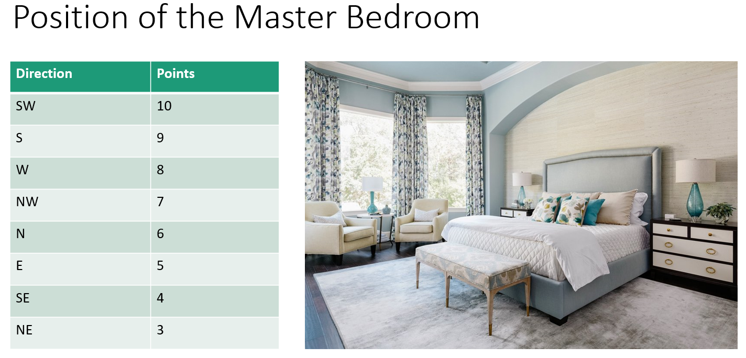
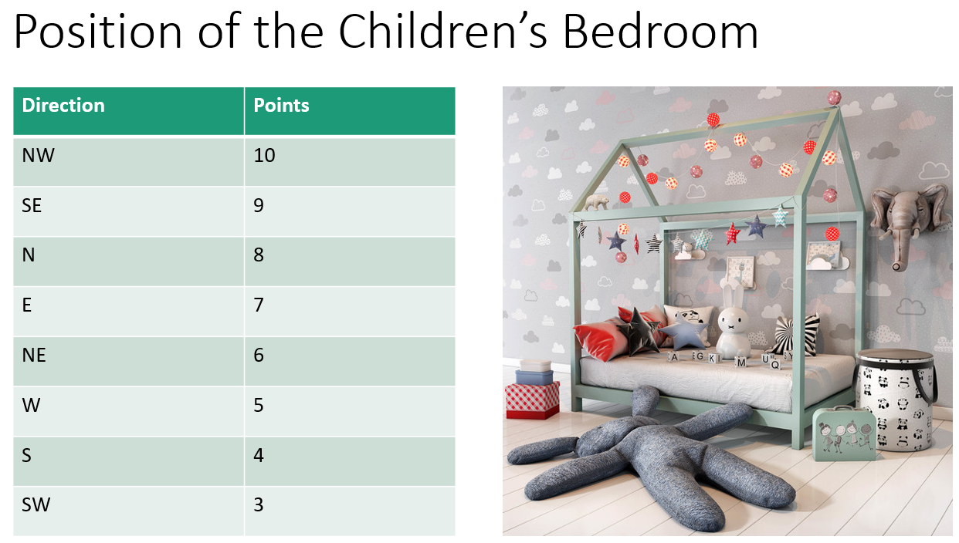

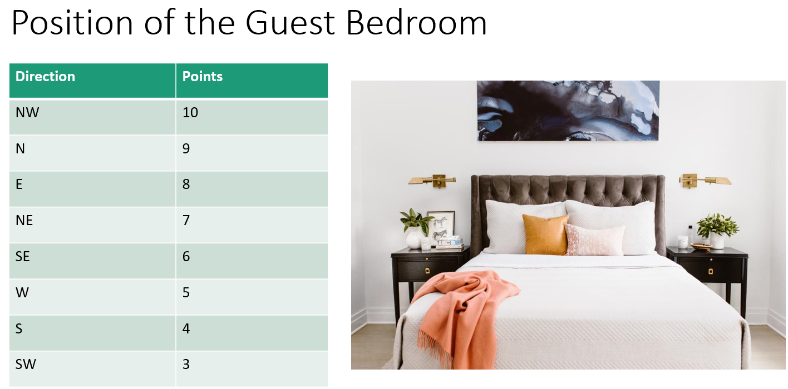
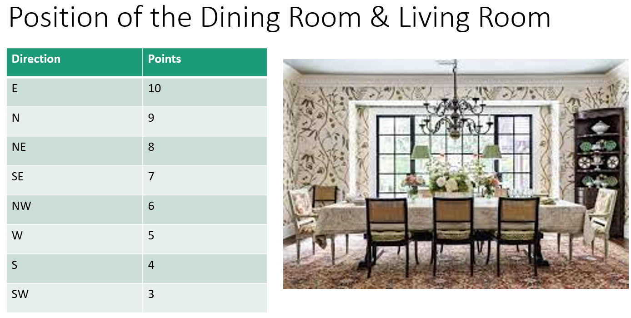

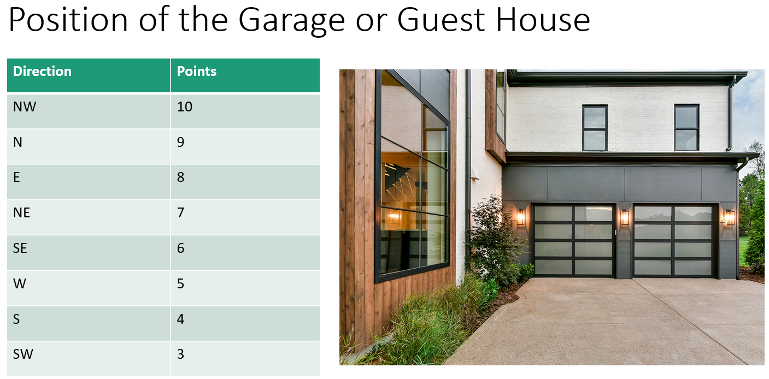
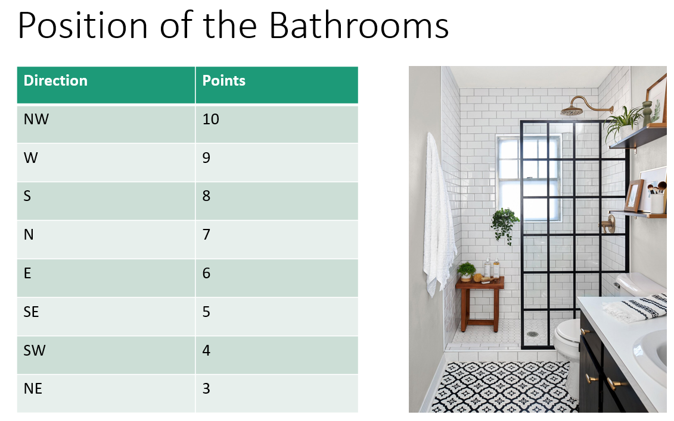

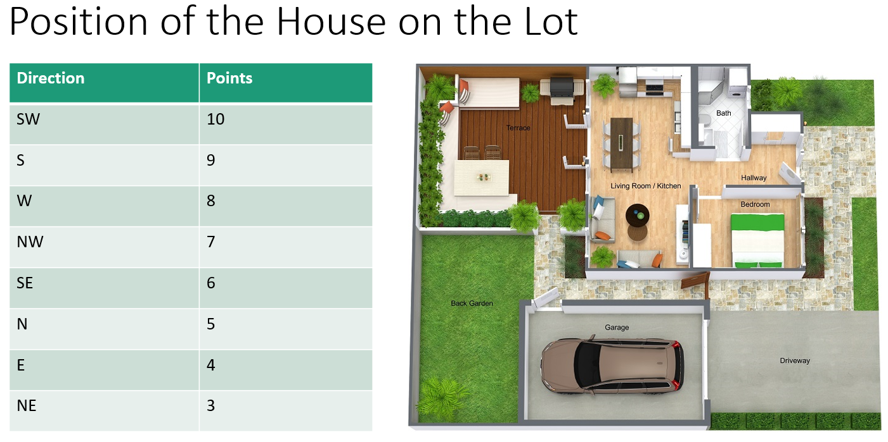
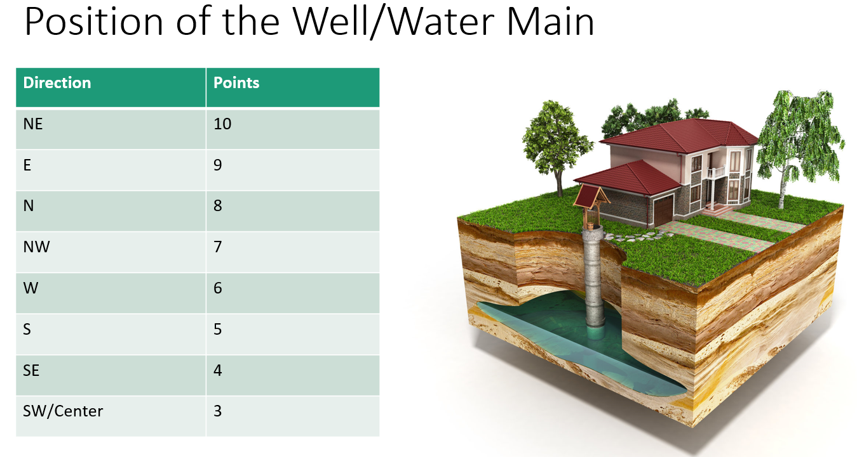

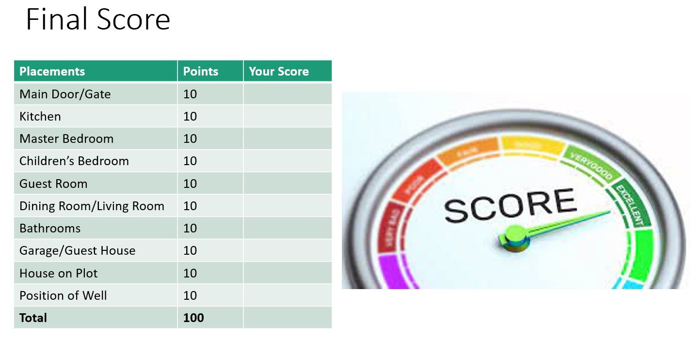

If your final score is 91-100% you have done well, and your energy ought to be flowing freely! If your final score is 80-90% you might notice some challenges in your energetic flow. If your final score is <80%, it’s time for a professional vastu consultation to optimize your health, wealth, and happiness. You can order our Professional Vastu Consultation package special here: www.DrKeesha.com/vastu .

Office Assessment

Your workspace can be a sacred space if it’s arranged in harmony with the elements and directions. It’s not necessary to have your work exhaust you. Here are some tips for starting the process of balancing the flow of energy for optimal health, performance, prosperity, and happiness:

- Have ample light, good ventilation, organized flow, no clutter, plenty of plants, and a water feature in the right place.
- The location of desk, computer, safe, electrical equipment all need to be carefully planned.

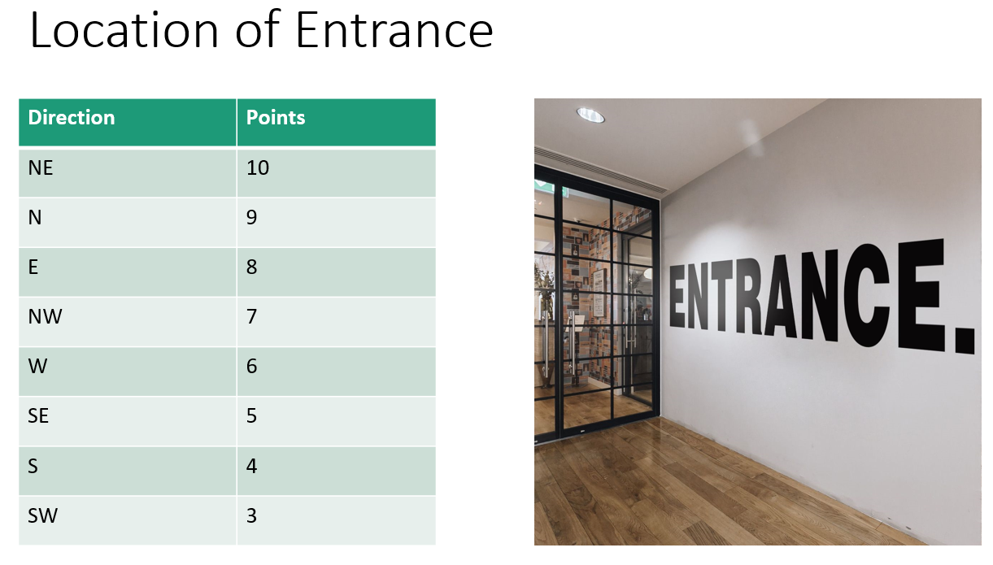
Ok…time to tally up the points for your office space…
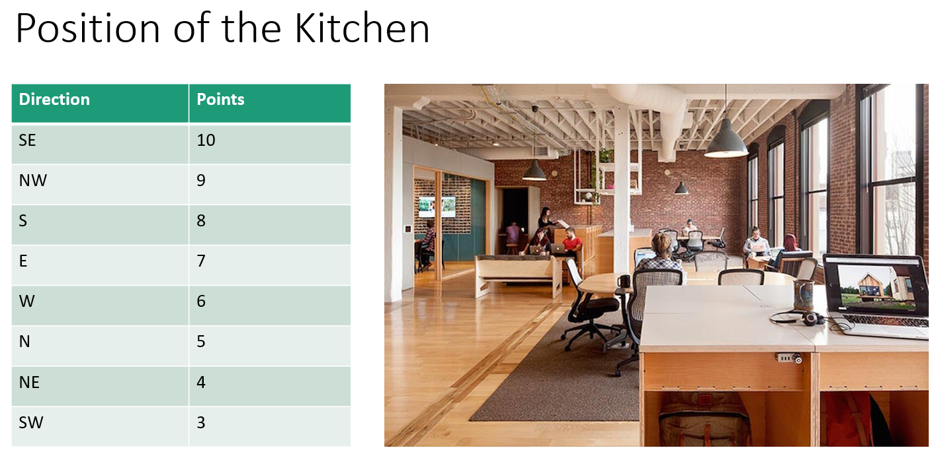

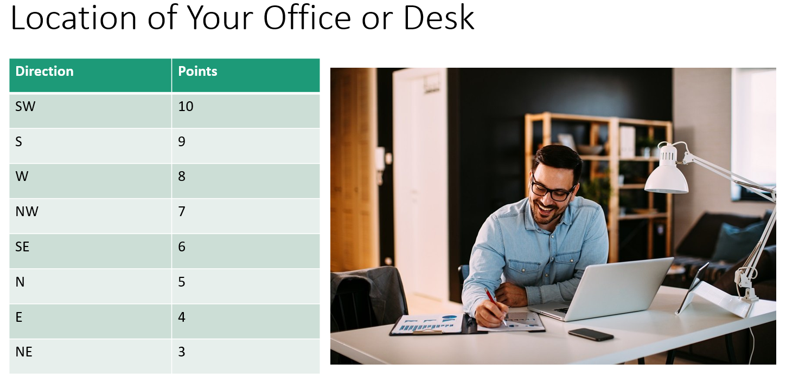

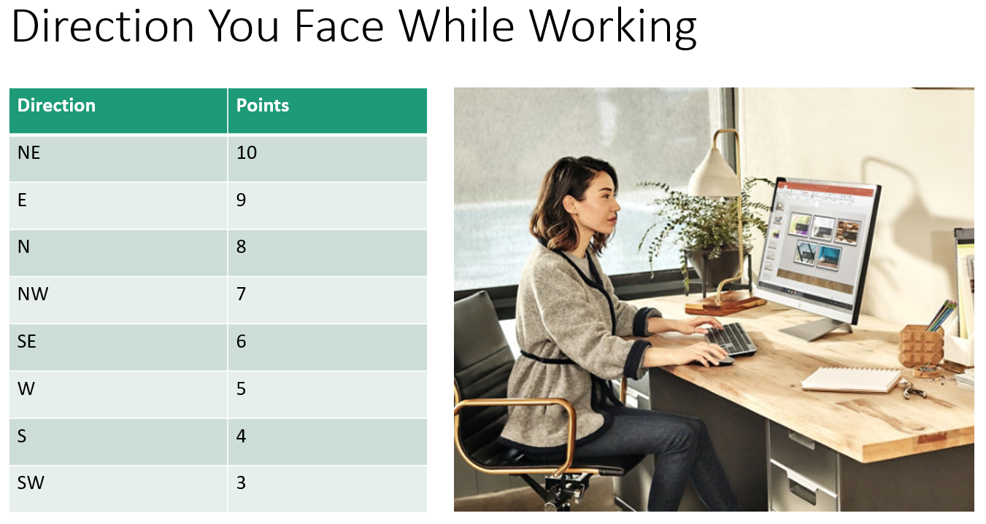

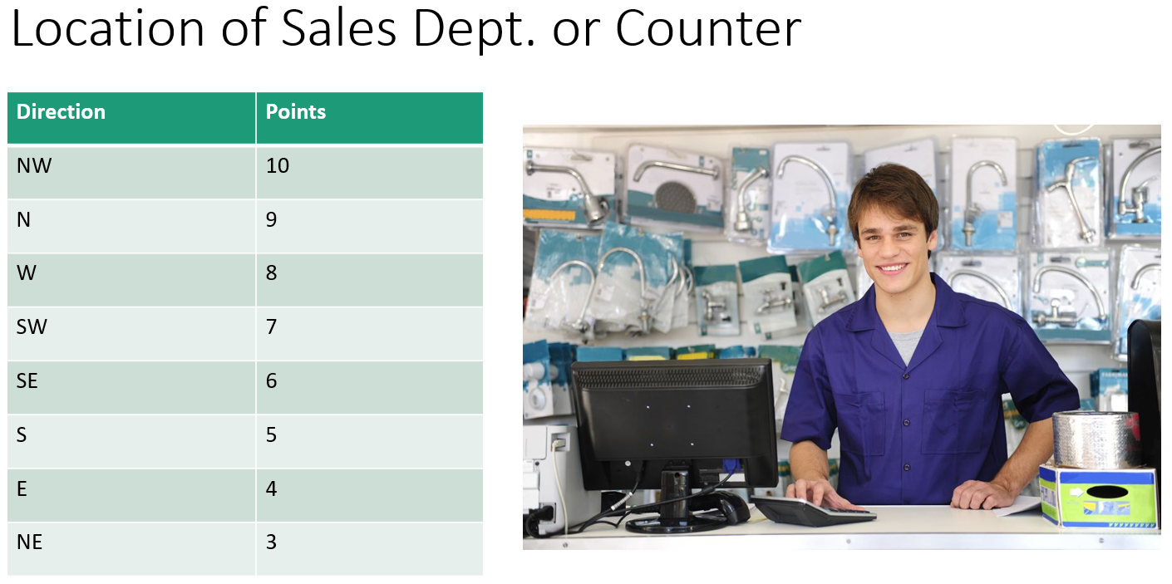

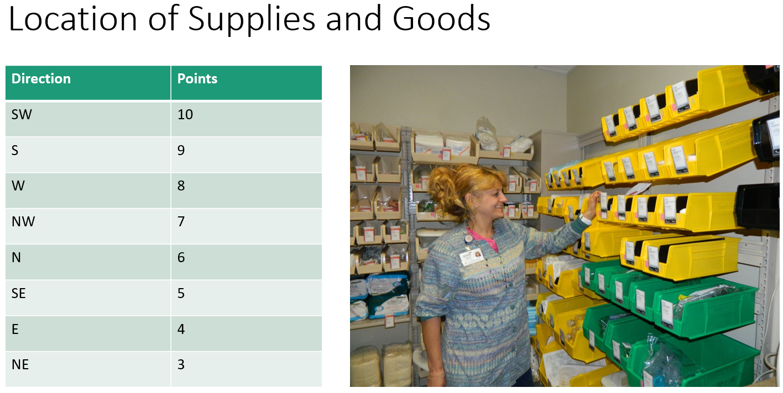

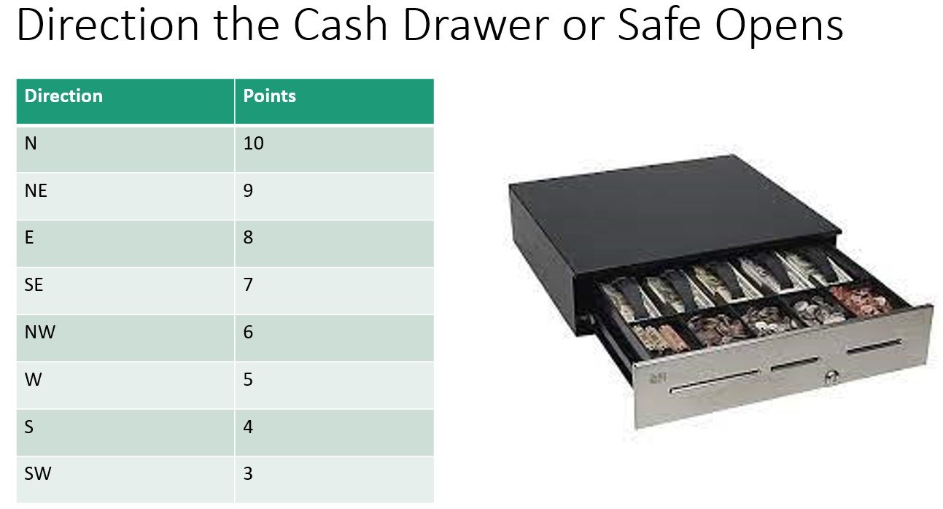

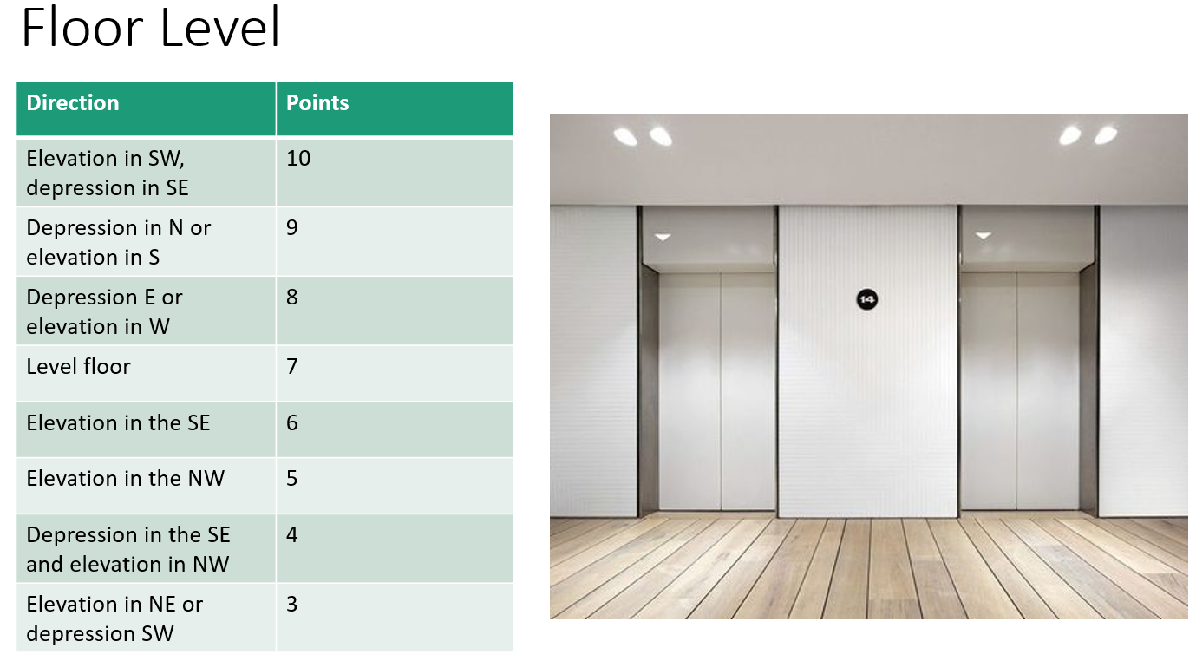

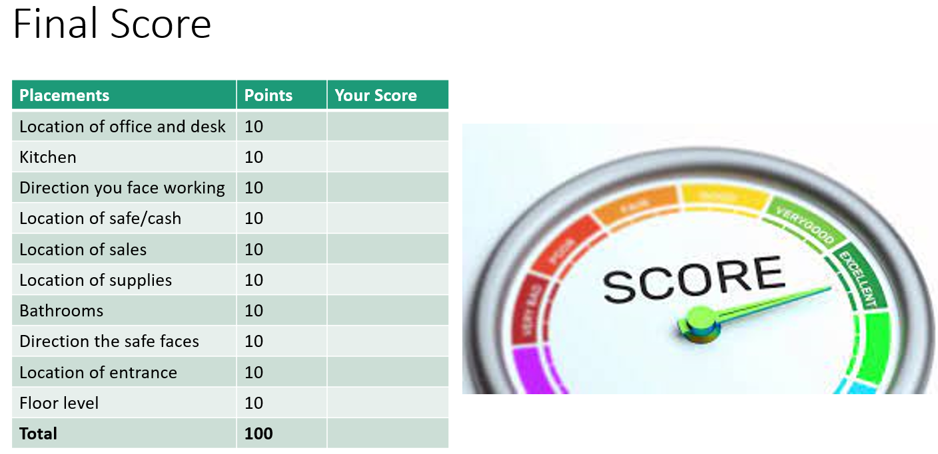

If your final score is 91-100% you have done well, and your energy ought to be flowing freely! If your final score is 80-90% you might notice some challenges in your energetic flow. If your final score is <80%, it’s time for a professional vastu consultation to optimize your health, wealth, and happiness. You can order our Professional Vastu Consultation package special here: www.DrKeesha.com/vastu .

Offsite/Online Analyses: www.DrKeesha.com/vastu
Vastu Shastra can enhance your health, support your prosperity, and bring you the harmony and fulfillment we all want in our lives.
Making simple adjustments to your environment can bring about positive changes in your life: Enhance your relationships, create more abundance, feel an incredible sense of peace and well-being at home or at work. These are just a few of the results that some of our clients have expressed after implementing the suggestions we have advised. Your in-depth, personalized analyses – for a variety of home or workplace settings – can show you exactly what you need to do.
These analyses are very detailed and comprehensive. Once we compile all the information, we will send you a customized analysis explaining what simple changes you can make to achieve your desired results. Our in-person analysis service can cost up to a thousand dollars. Click now and receive the same personalized service at an incredible savings!

About Dr. Keesha Ewers and Ajayan Borys
Keesha and Ajayan combined bring a wealth of experience in Eastern and Western philosophy and a variety of healing modalities.
Keesha is both a western trained Advanced Registered Nurse Practitioner (ARNP) and is board certified in Ayurvedic medicine, the ancient eastern science of how to live your life according to your unique constitution. Keesha holds a doctorate degree in sexology and is the Mother of a new branch of medicine she calls functional sexology. She is also board certified in functional medicine and a certified vastu shastra consultant, conscious dying doula, MDMA assisted and trauma informed psychotherapist, certified energy worker, yoga and meditation teachers, and the founder and medical director of the Academy for Integrative Medicine health coach certification program.

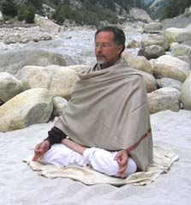
Ajayan has been exploring and teaching a variety of meditation practices since 1970, including several years studying in residence under Maharishi Mahesh Yogi (TM). In the 1990s Ajayan studied and lived with Mata Amritanandamayi (Ammachi, the "hugging saint"). Ajayan (Henry James Borys) is also author of The Way of Marriage: A Journal of Spiritual Growth through Conflict, Love, and Sex, The Sacred Fire: Love as a Spiritual Path, and numerous articles on meditation and relationships as a spiritual path. Ajayan is a certified vastu shastra consultant, a certified hypnotherapist and enneagram practitioner, an avid and prolific meditation teacher, and the author of Effortless Mind Meditation, Whispers of the Himalya, and several online courses on meditation.

